JDM Zenki S14 SR20DET Wiring into a DOHC USDM S13 Chassis.

By Rob Webber a.k.a. mestizo

***I AM NOT RESPONSIBLE FOR WHAT HAPPENS TO YOUR CAR IF YOU USE THIS GUIDE, IT IS FOR INFORMATIONAL PURPOSES ONLY!***

KA Gray Plug at the front right side of engine bay to the S14 SR20DET Harness wires.
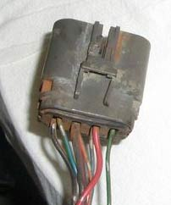
Back of plug
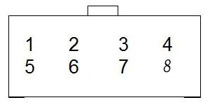
S13 Grey Plug Wire | S14 Wire
1) Green/Blue – Ambient Switch
2) Black/Red – Ign. Switch | Black/red on int. plug Pin 40 & 38 (IGN Coil Relay)
3) Red – ECU backup power | Red on interior plug Pin24(Red wires on ECU Relay)
4) Green/Yellow - A/C Relay
5) Black/White – ECU Power
6) Orange/Blue – Condenser Fan Relay
7) Blue/Green – A/C FICD Sol. Therm. Cont. Amp.
8) Yellow/Green
Revision 1

KA Brown Plug at the front right side of engine bay to the S14 SR20DET Harness wires.
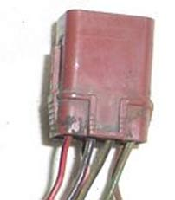
Back of plug
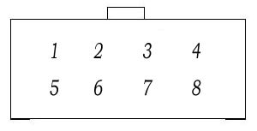
S13 Brown Plug Wire | S14 Wire
1) Brown – +12v Switched for Sensor Power | Brown Pin 21 & Red/Blue Pin 48 on interior plug
2) Yellow/Red – 4th gear sensor
3) Pink - PAIRC
4) Yellow/Blue – 5th gear sensor
5) Green/Orange – Neutral Switch | Green/Orange Pin 4 on the interior plug
6) Black/Yellow – IAC Power | Black/Yellow on Pin 23 on the interior plug
7) Black/Pink – Fuel Pump Relay | Black/Yellow Pin 30 on interior plug
8) Red/Black – ECU Relay
Revision 2

Interior Plug on DOHC S13 Chassis to Interior plug wires on S14 SR20DET Harness wires.
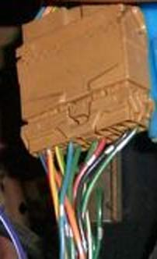
Back of plug
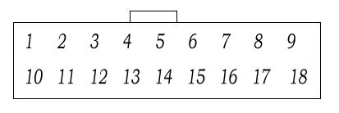
S13 Brown Interior Plug Wire | S14 Wire
1) Blue/Black - Temp Sensor | Yellow Pin 12 on interior plug
2) Yellow/Red - Tachometer | Blue/Black Pin 11 on interior plug
3) Yellow/Green – Speed Sensor | Yellow/Green Pin 13 on interior plug
4) Blue/Green – A/C Therm. Cont. Amp.
5)
6)
7)
8)
9)
10) Orange – Start Signal | Orange/Blue Pin 22 on interior plug
11) Green – Consult SCV Solenoid | Green on interior plug (Optional)
12) Green/Black – Consult Rx C.U.D.R. | Green/Black on interior plug (Optional)
13) Green/Yellow | Green/yellow on interior plug (Optional)
14) Green/White – Consult Clk. Sync Signal | Green/White on interior plug (Optional)
15) Red – MIL / Check Engine Light | Orange Pin 20 on interior plug
16)
17)Black – Consult Ground | Black wires on interior plug
18) Green/Red – CLK. Data link for Consult | Green/Red on interior plug (Optional)

Interior Plug on the S14 SR20DET harness.

